**2018 ANO Retreat Agenda**

8:30am - 9:00am: Breakfast & Retreat Kickoff

9:00am - 9:30am: Agenda Introduction and Roadmap Expectations

9:30am - 11:45am: Topics

* Core Code Contribution
* IP Issues (Patents & Trademarks)
* Licensing/CLA
* Nonprofit Setup
* Standing Parties
* Incentive Framework
* Community Governance Document
* Committee System

12:00pm - 12:45pm: Lunch

1:00pm - 3:30pm: Continuation of Topics

3:30pm - 5:00pm: Finalize Roadmap (General, Marketing, and Technical Roadmap); 2019 and Beyond; Goals and Strategies

5:00pm - 6:00pm: Dinner and further networking

7:00pm - 9:00pm: Texas Bitcoin Conference Kickoff Party

**\*\*\* Start of Meeting \*\*\***

**Opening Remarks:**

**David Chapman -** Thanks to Factom Inc for their perseverance and efforts to create an incredible project and ecosystem. We don’t talk about that a lot and I wanted to take some time to recognize their contributions.

**Paul Snow -** Factom Inc created the ecosystem but it requires decentralization and we need to get to the point where people are criticizing other ANOs as much as they criticize Factom Inc as that shows true decentralization. Factom Inc’s priority is to scale so want to make that clearly is the case. The goal of Factom Inc has always been to create a decentralized system that supports the people in the chairs today (other ANOs).

**Xavier -** We have limited time so need to follow up all topics with actions. Need to address the fundamentals first.I want to start with the roadmap, let’s get people’s opinions on that. If we don’t agree on the roadmap, then it will affect all of our discussion topics.

**\*\*\* Roadmap \*\*\***

**David Chapman -** Roadmap is both forward looking and backward looking. It defines where we want to go but also defines what we’ve accomplished so far. We need a historic roadmap as well as a future roadmap to put on the neutral information website

**Carl DiClementi -** We should keep the roadmap to vague things not specific things. If we say “sharding”, that is a specific thing, but “TPS improvements” can be achieved in any number of ways. Roadmap should be more focused on goals rather than specifics: e.g performance instead of sharding.

**Maarten -** I agree with that Carl but from the marketing side there are a number of buzzwords such as sharding which people look for in roadmaps.

**Brian Deery -** We also need to be careful when planning to ensure that we group together non-backwards-compatible upgrades to avoid telling followers and exchanges they need to upgrade every few weeks.

**Sebastian -** I noticed originally we were discussing the idea of a multi-decade timeline, then shorter, then a public one. I think that the scope of the timeline on the public side we need to discuss what makes sense for the external one.

**Carl -** That’s two timelines: internal vs external. Internal timeline is a prioritized list of what you have.

**Ben Jeater -** We need to be clear that a roadmap is not a timeline. We don’t need to put dates against things, just lay things out in order of priority.

**Zach Lynde -** We also need to be sure that we achieve what we say we are going to do. As the keepers of a trust engine, accountability is an important issue. We want people to trust us. In two years we’ll be talking about items today we don’t even think about as important now. We need to establish ourselves as the trust keepers.

**David Chapman -** I suggest that the historic roadmap is really simple. M1, M2, M3, decentralised Dev (Paul Bernier’s accepted commit). What should we do next? Performance improvements?

**Brian Deery -** Performance improvements are complicated because we can’t create firm numbers for the current performance. We may need to put “governors” into the code to ensure that we don’t exceed tested stability limits of the code.

**David Chapman -** What can we put into Q1 for 2019?

**Paul Snow -** Let’s make a list and work on the priorities/order once we have the list.

**\*\*\* Team begins suggesting list items while David add them to the whiteboard\*\*\***

**Niels -** Add decentralized identifiers to the list. Should be part of the roadmap as we’re one of the few blockchains actually pursuing this.

**Dennis B -** Add hardware wallets.

**BenJ -** Add stablecoin to roadmap.

**Sebastian -** Add voting to the list.

**DavidK -** It should be a priority to create an ecosystem that developers who want to build on Factom can come in and learn quickly. Ethereum is a great example of a developer-friendly ecosystem. I’m not talking about core development but building on top.

**Sam -** I agree with adding on-chain voting to the list.

**Julian -** Comprehensive Factom dev documentation and smart contract functionality.

**Paul -** We will be refactoring the code and I’d rather do documentation after the refactoring.

**\*\*\* Moderator interject once suggestions die down\*\*\***

**Xavier Chen -** We can continue adding to this list for another hour, but we need to move on to the rest of the agenda. Reminder that as we go down the list of topics, all of our discussions should gear toward action items. Those action items will be added to this list which we will circle back later during the day. During that time, we can prioritise the items and put them into two separate roadmaps (internal and external) as suggested by couple people. This roadmap will be shared with rest of ANOs before sharing with the general public.

**\*\*\* Core Code Contributions \*\*\***

**Xavier Chen -** Can Paul (Snow) or Brian (Deery) update us on where we are with core code contributions from the community?

**Paul Snow -** The MIT licence that we are using at the moment allows others to licence the open-source software themselves. Other licence types don’t allow that. By signing the CLA (Contributor License Agreement) it means that you can keep the right forever to licence the software you have written and Inc will be able to change the licence if needed.

Nothing about the CLA affects your rights on the code. It allows Factom Inc to relicense the code in the future. To preserve the rights you have to sign it. Once you sign it your contributions come in under MIT and the CLA says we can change it in the future. You need to sign it for us to pull it into the codebase. I want to encourage all of you to sign the CLA so we have the option of bringing your stuff in. I really am so pumped that Brian put this in so quickly--via the emergency release. It’s super great from my perspective that I can go on the Discord and say “it’s all on you”.

**Brian Deery -** Three aspects:

1. The ability to preserve our multi-decade timeline

2. Just looking at the number of lines of code is the wrong approach. It requires many hours of debugging to find one error in the code.

3. Testing. The testing is much harder to show. A single line of code getting changed can have extensive testing behind it. The testing is sometimes as hard as writing the code itself. Just because a pull-request exists doesn’t mean it’s passed the third barrier of having testing. Writing unit testing takes a lot of time and it’s something we would really appreciate the community helping with.

**Paul Snow -** Yes, please contribute to the unit testing where you can. It’ll really help us judge the quality of you as developers and get you comfortable with the code base. Keep in mind you can put unit tests into your code and we can run your unit-tests to verify it works. We can pull in unit tests because we know that your unit tests can’t break the main code. This is a great way for developers to get started because it’s a low-risk but hugely beneficial way to contribute. And starts a list of people who are listed as contributors which is exciting and a good look to the outside.

**Xavier Chen -** This topic is suppose to be about core code contribution, unit testing is related to that topic but it sounds like Licensing/CLA is a prerequisite to that discussion. Instead of trying to mix the two, why don’t we jump ahead to CLA first then we move back to testing environment and core code contribution?

**\*\*\* Licensing/CLA \*\*\***

**David Chapman -** Why do we need to sign the CLA now? Why can’t we sign it if you ever go to change the licence?

**Davidk -** I think that it’s great you’re pulling in developers. I read your reasoning several times but it seems like we could make the CLA at the point in time that we move out of MIT.

**Paul Snow -** I have to have the CLA cover every contributor so if we do it later I’d have to backtrack and get every contributor to sign it in retrospect. We would then have to go back and talk to ALL the developers who contributed, and some may no longer be in the community. That would cause issues. The MIT doesn’t give ownership. It’s actually ownership that lets you change the license. The MIT license doesn’t give us that level of control. The only aspect of ownership we want is the ability to change the license of the code.

**Zack -** We don’t know what the future holds so are trying to plan for the future. Contributors still publishing under MIT so you still own your code contributions.

**David Chapman -** I know Inc’s motivations are pure--

**Paul -** As driven snow. *laughs*

**David Chapman -** What if Factom Inc get acquired by another company and they change the licence to something proprietary? If they make decisions that the ANOs don’t like, how would we handle that? Then comes the question of “do we have to fork?” and we haven’t defined what the main chain would be in that case. If the existing ANOs decided we didn’t like the direction the new company was going who would have the exchange listing for the FCT codes.

**Zach Lynde -** The Factom Foundation owns the code, not Factom Inc. The publisher of the code is actually the Factom Foundation, not Factom Inc. That means that Inc can’t change the licence.

**Chapman -** So in Factom Inc is acquired how is my scenario not plausible.

**Zack -** You have to follow that with “right now”.

**Chapman -** I have to think to the future.

**Zack -** Let me clarify. It’s certainly true for today and there’s no acquisition on the radar. At least a year away.

**Chapman -** I think it should be worked out now rather than have to take away or add in the future.

**Niels Klomp -** Why is the CLA written between the developer and Factom Inc then? Why not with the Foundation if they own the copyright? I’m a little worried about the centralization in the CLA. I think we can solve that rather easily by making sure other parties are named in there. What I don’t get is that the Foundation has the copyright right now and every source file has the Foundation’s name on it, why is Inc on the CLA.

**Zack -** It has to do with who is paying for Github

**Niels -** So the Foundation is paying for Inc to do the coding. So why does Inc need to be in the CLA?

**Zach Lynde -** We’re a principal agent. The Foundation doesn’t even have a bank account. Factom Inc is acting as the principal agent for the Factom Foundation.

**Niels Klomp -** So the Factom Foundation should be the company on the CLA?

**Paul Snow -** Factom Inc pays for the Github account that is used for the code base.

**Niels -** The Foundation has a chairman and a board. What is stopping the Foundation from being in the CLA.

**Paul -** The Foundation is very inactive and there’s no intention for it to continue.

**Zach Lynde -** We should avoid putting things like that into the Factom Foundation because the Factom Foundation was created to protect people, not hold the code and finances.

**Paul Snow -** To clear things up, the acquisition issue could happen under the MIT licence as well. There is nothing stopping that.

**Zack -** There are no smoke and mirrors here. In 2014 there were people going to jail and the UK was crypto friendly so we created the Foundation to protect Paul et al but the way UK tax law there is a lot of liability there so the codebase can’t go back to the Foundation. Speaking frankly, there isn’t a plan for Factom Inc. to secretly acquire the codebase. We’re working with the community to come up with an approach to make this work. The codebase is not an asset we list on the books when talking to investors. If anything we have to defend to investors the money we put into developing the codebase. By putting the CLA in there it protects the Factom community and you.

**Xavier -** We’re about twenty minutes into this particular topic let’s start thinking about solutions or action items.

**Paul -** If we didn’t have a CLA Chapman’s scenario is still viable. Without the CLA you’re in the same boat that you’re projecting with the CLA. The CLA gives me the opportunity to hand it off to someone else and then be acquired to avoid the situation. The worse we can do as bad actors is devolve you to the rights you already have under MIT. There has to be an entity that the rest of the world recognizes to have the right to make changes.

**David Chapman -** It’s a great point that it can happen without the CLA. On the forum I asked on the forum if you’d be ok with changing the one line to “with the approval of standing parties”.

**Paul -** If you did that, somebody could file a suit and in front of a court you have to define what it meant for the standing parties to approve and then the standing parties are in court. Being a decentralized protocol we don’t want to expose our standing parties to legal issues.

**Chapman -** That could happen under any standing party vote though. Is there way to add governance to it?

**Paul -** Factom Inc is willing to commit to listening to standing parties on this matter but writing them into the legal doc (CLA) doesn’t buy you anything.

**Julian -** I agree with not looping standing parties into any legal issues.

**Matt -** Can we specify in the CLA that the code remains open source?

**Paul -** That breaks MIT. I don’t see us joining a Foundation. We’re not compatible with Hyperledger, etc. This is a 1% chance distant in the future that we would want to change our license and then change it back.

**Zack -** I’m also willing to take this discussion offline. We’re not running from this we are willing to continue this discussion later as the community wants.

**Sam Vanderwaal -** Can we put a clause into the governance that requires ANOs to sign off on licence changes? Can we move the language from the CLA to governance documents? Does that make sense?

**Brian Deery -** I would be against that because it would close down options. The CLA language gives us more options not less so this discussion is weird to me. We shouldn’t be talking about restricting our options.

**David Chapman -** We don’t want to take options away, we just don’t want Factom Inc to have sole control of changing the licence for the protocol software.

**Brian -** What I’m hearing is that we want to have Factom Inc and others have the control.

**Chapman -** I don’t want to see them separate. I want Inc to be part of the standing parties.

**Zach Lynde -** May I take an action myself to research if we can keep the CLA as is, plus add a statement to the governance to determine consensus for licence changes? Action item to carry this forward: legally I don’t think we take it out of the CLA but if we research that it may be possible to look at where we put it in the governance. To Brian’s point we preserve the option in the CLA and we look at how we decide to change to the license via governance.

**Paul -** The only code that matters is the code that gets deployed. If ANOs don’t deploy code under a new license it doesn’t happen.

**Chapman -** Say Oracle takes it over and are friends with exchanges we have ourselves a very serious problem.

**Zack -** My action item is to sit down with our open source attorney to clarify a few questions about CLA especially Inc vs Foundation. We can’t take the CLA out of the Github process because of informed consent etc. we want to make it clear that’s happening. But we will try to come back with a suggestion for how to put this into governance.

**Julian -** I think of it more as a way to help safeguard Factom Inc than the entire ecosystem. If Inc decides to go under Apache and the rest of the system doesn’t the governance doesn’t hold them accountable because they’re no longer under it. Putting it in the governance is another metric of decentralization.

**Brian -** We shouldn’t conflate forking the codebase and the network these are two very different things.

**BenJ -** The wording I’ve got: Zack is taking action to research to see if we can keep the CLA as is but add a method for determining consensus to change the license.

**\*\*\* Group agrees with the action proposed by Zach Lynde \*\*\***

**Xavier -** Back to the core code contributions

*Action Item: Zack is taking action to research to see if we can keep the CLA as is but add a method for determining consensus to change the license.*

**\*\*\* Core Code Contributions \*\*\***

**David Chapman -** What’s the best method for getting new developers to get up to speed on Factom code.

**Paul Snow -** This is very personalized. A very very good developer could get up to speed on their own in a few weeks if they compartmentalize what they focus on. There are a lot of people who learn by working on the code. A lot of devs don’t want a lecture but rather dig into the code. Three months from now I hope we have more options than sitting in Inc’s offices but that’s a valid approach if people want.

**Carl -** This gets into the decentralization of development roadmap item. Some of the subtasks that come out of that is Inc needing to figure out this answer. There’s nothing that frustrates people more than contributing and having their work thrown in the garbage. So we need to figure out as INc how to do this a subtask under this roadmap item.

**Brian Deery -** The way people will be productive is exactly what Luap (Paul Bernier) is doing. He has a problem he’s interested in that he wants to solve and he learns what he needs to about the tiny section of the code that fixes the problem that he’s working on. Then he understands that well enough to submit new contributions to that. Once the developer understands that small segment, as they uncover how that works they can start expanding how other things work. As the tendrils of understanding go into the different parts of the code by solving a problem you’re learning.

**Carl DiClementi -** I disagree because I don’t think that way of working will scale well. If everyone is doing this as a hobby, sure, but once people start investing money into and are trying to really help build the protocol it’s going to bring it in different ways. If you start building something that isn’t in the roadmap it may impact other people’s projects. People need to contribute in a way that drives us in the right direction.

**Maarten Boender -** I disagree that it won’t scale. Just look at all the other open-source projects out there like Linux. I think there are enough open source projects that prove it can be done.

**Niels -** It boils down to having a roadmap so everyone works into the right direction. Onboarding new developers and having them refactor and get them to really understand it so they contribute more in the future is the way to do it. You have the benefit of short term goals of stability and you have the benefit of longer term contributions later.

**Zack -** This was a conversation Julian and I had around this and for me it’s all about stability.

**Xavier -** Is there an action item we can take from this topic?

**Paul -** Let me add an action item: Create a Factom Improvement Protocol (FIP).

**Sebastian Fletcher-Taylor -** We need a method to ask the community “I want to do this in the code; is that ok?”

**Paul Snow -** We need to create a Factom Improvement Process (FIP) for things like that.

**Zach Lynde -** Yes, we definitely do.

**Niels Klomp -** I will take the creation of the FIP as an action.

**Xavier Chen -** What is Factom Inc’s capacity to handle external developers? Most important thing for an ecosystem is to increase the capacity (of developers). We have two in the grant from Spheron, possible Adam and Paul and maybe Chapman’s developer later. Is there limit to how many we can add?

**Carl -** Let’s make action item from this.

**Paul Snow -** The more developers we have onboard, the greater our capacity to handle new developers. The community needs to put forward developers by signing the CLA and we will onboard them. Let me clarify the action item: The more people we onboard the more resources there are to help bring new people onboard so it’s an exponential benefit once we get started. So I can commit Inc to do whatever it can within its power and resources to get this process started. We can commit to supporting 1 to 3 developers.

**Zack -** Can the community put together a list of developer resumes for us to review?

**Carl -** Not resume, skill levels.

**DavidK -** One point is that we know Inc has testing but we don’t know anything about it and know about it will help us know how to contribute code.

**Paul -** When you put code in today it’s tested in CircleCI. Every unit test you write adds to our automated testing.

**Nolan Bauer -** Will the FIP cover development of testing coverage? Can we add that under the FIPs? We want to emphasize this needs defining under the FIP before we move on to the next topic.

**Paul Snow -** Yes, anything that gets submitted to Factomd will be covered by the FIP and CLA.

**Brian -** I want to show the nuance involved in it and boiling it down to a single action item is difficult.

**Xavier -** This will be for a detailed discussion among more technical people. It is not appropriate to drill down into the details for current audience due to time constraint.

**Matt Osborne -** Brian, I hope you live a super long life and everything but what happens to the protocol if something happens to you? How key is Brian Deery to the development of Factom? Should we be decentralising his knowledge?

**Paul Snow -** Factom Inc's other developers are covering most of what Brian Deery knows now. We are still working on that though. Between Steven Maisely and Clay and Sam on the anchoring side we are increasingly duplicating Brian’s abilities. The more people we put into dev ops the better. Let’s put decentralized boot sequences into the roadmap list. Again, the community can help by putting developers forward.

**Brian Deery -** I just want to add that we know we need to decentralise startups.

*Action Item: Community to put together list of devs*

*Action Item: Inc to determine the capacity of devs it can bring in.*

**\*\*\* Intellectual Property Issues \*\*\***

**Xavier -** This was brought up in the community. Maybe someone from the legal review group can discuss this problem and identify action items.

**Julian Fletcher-Taylor -** Intellectual Property (IP) is a complex issue that we need to be explained to the ANOs and community. More than anything we need to have it out there and explain very clearly how we can use the term Factom and how we can use logos. Even for the factom protocol website I have yet to get a clear answer beyond I “probably” and “I think so”. We need to know. Building the website isn’t a little thing, we want to go live with it next week and I’m worried about having to take things down because of branding confusion or whatever. We’re still not sure what logos we can use, and if we can even use the Factom name.

**Spencer -** I’m the lead for the website. IP is an issue, even with the entry credit logo. Do we need to create our own or can we use an existing one?

**Zach Lynde -** I’ve been working with Julian and Matt and the team to bring some clarity to this. To set the stage quickly, in 2014 we stated not knowing when it would be released. Trademarks are there to prevent the confusion in business. A trademark is an adjective. It’s not necessarily the name of a company but if it causes confusion with the name of a company it can be enforced. Today Inc has three trademarks. We don’t have one over an Entry Credit logo. We talked about giving up factoid.io for the exchange committee to have emails. The three trademarks Inc owns: The world logo with the arrows around it. We can grant that license to the community. As it works in trademarks eventually that will become like the term “Kleenix” (ends up in common usage and can’t be trademarked) and won’t matter. As it relates to Factom Inc, we own the name Factom and we own the globe with the stripes on it. The name Factom can be confusing. We have a license drawn up, for five bucks a year we can license the name Factom. For example, to Factomize LLC. The only thing we would ask is for you to spend the ten bucks to do it as DBA. As it relates to the name Factom, we have the contract already, we’re getting ready to release our new website and all the licensing will be ready. It’s our goal to give the community the logo with the arrows around it. Where it gets sticky is Fatom Inc as a private company we have investors so we have to be careful about other companies that make products with the name “Factom” in it. There’s a willingness on our part, but our hands are a bit tied as we had to make decisions as early as the first seed round that hamper us now. Those decisions allowed this entire ecosystem to even exist.

**BenJ -** My company name doesn’t have Factom in it but if I say “I am using the Factom protocol” is that a problem? If my customers dig into it a bit further does it mean Inc or the protocol developed by Inc.?

**Zack -** This is the difference between when they wrote about Factom securing the (something) in China. If you just use it as a protocol you’re using it’s different then if you come out with a product that has Factom in it. But we can work it out via a perpetual license.

**BenJ -** If we use the globe with arrows and say “Secured by Factom” is there an issue with that?

**Zack -** That’s using a trademark incorrectly. You’d want to say “Secured by Factom Technology” or something because the trademark is an adjective.

**Chapman:** *shows “secured by Factom” on the Factomize forum.

**Zack -** We can work out a license for that. Where it becomes an issue is business to business. Eventually this will become Kleenix and won’t be protectable but it is right now.

**Carl -** In our releasing of the new website we’ll make an action item to provide clarity to the community on how to properly use these things.

**BenJ -** I’m asking as the chair of the marketing committee on how to put this into a branding document, etc.

**Carl -** Clarity on this will be part of the website launch.

**Spencer -** In terms of a press kit, what is the general timeline for that?

**Paul -** If you look at Linux, they’ve managed to keep their trademark despite the fact there are many version of Linux and companies built on using Linux. To the extent we want to manage the usage of the terms relating to our protocol, it becomes a community thing but has to sit inside a legal entity. Linux trademark is actually owned by Linux Torvalds and license to the Linux Foundation. We have some severe issues with having a Foundation that Linux doesn’t have. The question is whether we want to be more like Kleenix or Linux.

**DavidK -** Just want to add that for MyFactomWallet we’re also interested in this issue. It’s a free service so we want to know how this plays out.

**Xavier -** Beyond just providing a website explaining the IP held by Inc. We also need a direct line of communication. Otherwise you’ll get a barrage of questions coming from ANOs asking about their specific use case. Lack of answers or vagueness in answers will create bigger problems. Maybe we should have a Q&A for the ANOs with some of the more common questions along with the release of the website? Also a point person from Inc.

**Carl -** I can’t promise that will be part of the release--scope creep but it seems like a good idea.

**Jay -** That’s a good idea. Inc Marketing will do that but not necessarily at the same time as the release of the website.

**Zach Lynde -** Jay Smith and I will take an action to create some information about what can be used by the ANOs and community, and how it can be used. We will also create a Q&A regarding the licencing and use of factom logos.

**Jay Smith -** I will also talk to Ben Jeater as chair of the marketing committee to establish a direct line of communication between Factom Inc and the community marketing efforts.

**Niels Klomp -** There are certain patents Inc applied for which is an issue for a company like ours, Sphereons, we have integrations into document management systems. You’ve created this really nice solution, we are all here because you created it, but what is stopping you from coming after the organizations making solutions on top of the decentralized network?

**Paul Snow -**  A couple of observations: Using the protocol itself under MIT does not obligate you to do anything beyond comply with the actions it specifies which is to provide the software license with your products. It becomes fuzzier when it gets closer to the core protocol. I would point out that Bank of America has 45, various others have many patents. These are the filings that are released, they are released 18 months after the filings, this is probably 10% of total patents in the space. Your real concern is all the other companies. Inc has been filing as defensive measure. We have 22 filed and more in process. I encourage other ANOs to file patents and are happy to help and collaborate with other ANOs. It also significantly improves the marketing to have Factom related patents. There is an organization, some collective defense org. They are the ones that stopped the patent wars on cell phones. This was when all the lawsuits regarding cell phones stopped in 2013 because this join defense org holds a otn of patents and to be part of it you can’t sue other members. Patents help Inc with investment and Inc is the tiniest threat in this space. At some point if a patent war were to erupt Inc would be hurt like everyone else. Strategically, we should all be filing patents now but at some point we maye need to join this organization or one like it to protect us. My advice is you should file as many patents as you can for blockchain so that when the war comes you can join the blockchain protection alliance. If you need help, talk to me.

**BenJ -** The patent solution in Europe is much different. Can we work something out where a EU or Asian ANO could get help from Inc to file patents in the US.

**Paul -** Let’s have an offline discussion, I’m willing to help.

**Zack -** Just to point out, the patents that have been announced are only the ones in the US.

**Julian -** Concerns about the broadness of patents.

**Paul -** That’s how you write them. They’re all as broad as possible.

**Brian -** Keep in mind, IBM spends millions on advertising alone. If we start getting successful, IBM will want to squish us.

**Paul -** IBM is a special case.

**Zack -** Budget wise plan for $10k for a patent. Five years for review.

**Xavier -** Is there such a thing as a blockchain patent defense group?

**Paul -** Not yet. The group I was referring to is campaigning to get blockchain organizations into their group.

**Julian -** We want factom.org at some point.

**Zack -** I have a few things to clear up but we can have that conversation in Q1 2019.

*Action Item: Have Q&A for the ANOs shortly after the release of the new Inc website.*

*Action Item: Someone from legal put together information for the community on patents.*

**\*\*\* Lunch \*\*\***

**\*\*\* Foundation Discussion \*\*\***

**Xavier -** This topic is to talk about a Foundation. What is the purpose of a Foundation or non-profit? Do we need it? If we do, how do we set it up?

**Julian Fletcher-Taylor -** The idea is: do we want some sort of structure that isn’t an ANO, so non-competitive, that can be tasked with fulfilling things for our ecosystem. Marketing, holding domains, and IP, etc. Their only job is to maximize the use of Grant money. They would be paid only in Grants. Wouldn’t compete with ANOs and wouldn’t have proprietary projects. Factomprotocol.org, for example, needs to be maintained and held by a legal entity. Currently it’s by DBGrow, but DBGrow has other projects. DBGrow shouldn’t be both creating enterprise solutions and being the curators of the content on the website (such as advertising enterprise solutions). I would like to create a foundation paid for my grants. It would be a non-profit and host the FactomProtocol.org website.

**David Chapman -** Just to let you all know, we are moving the Factomize forum onto the FactomProtocol.org website once it is launched. Part of the plan is for Factomize forum to become part of the NIW to decrease centralized control. It doesn’t do us good to transfer from Factomize to DBGrow, though. At the same time I have concern about centralization inherent in a Foundation. The foundation needs to be managed correctly to ensure that it doesn’t appear to be a point of centralisation, and I don’t think the directors of the foundation should be guides.

**Xavier -** An issue we have run into as the Exchange Committee is needing an address for listing applications. We can’t do that as decentralized entity.

**Chapman -** I’m supportive of a Foundation as long as its structured correctly.

**Nikola Nikolov -** The idea of a foundation is great, but it will need research. Can a lot of the jobs of the foundation be done in governance instead of a foundation? We have potential future regulatory concerns where government agencies may come looking for a centralized agency within the community and they’ll land at the Foundation. So it has to be set up correctly. The Foundation would open up a lot of questions we don’t have the answers to.

**Xavier Chen -** The fundamental question here is what would the purpose of the Foundation or non-profit be? Can we nail down the purpose of such an entity and then go from there?

**Paul Snow -** I know that part of this is to get Factom Inc out of the roles we play in the name of decentralization. I’m not seeing a lot of improvement in decentralization by moving from one centralized entity to another. Where we can make significant improvement is automating things like ANO elections and creating proper standing parties. These are more important than creating a Foundation. I’m a little concerned about Foundations I’ve seen in the past who have failed to performed as advertised and have attempted to be decentralized by bringing everyone in but everybody didn’t feel represented. It is treacherous. I’d like to concentrate on automation.

**Chapman -** How do you automate something like the Factomize forum?

**Paul -** I think a Foundation that handles the forum has limited liability and scope. It’s hard to sue anyone for publishing. In as much as the Foundation gets into governance we have a lot of problems.

**David Chapman -** Would you support going the other way where there was a steering committee of ANOs that tightly directed and controlled the Foundation?

**Paul Snow -** It is really important that the foundation is decentralised and having only ANOs be part of the process would not be sufficient to be decentralised. The 1st amendment (United States Constitution) protects freedom of the press, so the foundation could be used for marketing and publishing.

The problem is that the DAO gave everyone the participating rights but actually a small group of people made most of the decisions and the SEC decided it was still a centralized effort because voting by various parties had little to do with the decisions of the central committee. The point being, it’s not enough to have a lot of people, they have to actually participate for it to be decentralized.

**Chapman -** So just the ANOs would be sufficient?

**Paul -** Correct.

**Xavier -** Cardano’s foundation is another example. It ended up being centralized and controlled by one party.

**Paul -** If we’re just talking about publishing I don’t think we have a lot of risk. I trust you guys (ANOs) implicitly. Anything having to do with publishing and outreach to the community, coordinating, is fine. But once you start handling money and making monetary decisions you have massive liability.

**Shuang Leng -** To avoid issues, the scope of the foundation needs to be very small. The Foundation must also stay away from governance. The Foundation purpose should be very limited, shouldn’t be participating in Governance. However, the Foundation could handle IP. Even if controlled by a small group of people because the Foundation controls such a small part of the community it’s still limited.

**Paul Snow -** Can we make the foundation for publishing, forum hosting, and owning IP? Board of directors won’t have insurance will be liable for the mission of the Foundation which is why the liability should be kept limited. I don’t know about Europe though.

**Niels -** Much less strict in Netherlands. Board of directors have to be guilty of gross negligence.

**Paul -** Maybe we do this in Netherlands.

**Shuang Leng -** We can state that the foundation is for the public, or it is a non-profit but not tax exempt to get some more flexibility.

**Paul -** Most open source projects don’t have a market cap, though. So no matter what we do there’s money involved. Unlike Linux, for example.

**Xaiver -** So this is a complicated problem. What is the action item for this?

**David Chapman -** Sounds like there’s a degree of consensu for Foundation to do publishing.

**Paul -** IP, publishing and advocating for government. We need a body to aid governance.

**Julian -** It should be an entity which is entirely funded by the grant pool so the ANOs can cut off its funding and control it that way.

**Shuang -** The funding for the Foundation doesn’t have to be restricted to grants. The grants itself can have issues with the IRS as the money comes from the protocol. Who is the protocol? We should keep the options open for donations from ANOs. If it’s 501.3c ANOs can write off donations and it can solicit donations for other external entities. I really don’t think the Foundation should be part of the governance. The Guides should not stay under the Foundation as that’s a centralization issue. There are also non-profit but non-exempt entities that the Foundation could be.

**Julian -** There are a few more key pieces coming out in the coming weeks to start a broader conversation about this.

**Shuang -** The Foundation doesn’t have to be steered permanently, it’s just a tool for the community which can be dissolved at a later time.

**Julian Fletcher-Taylor -** The reason we need to have a foundation is because a foundation can be transparent with its finances and inner workings. We can’t be as ANOs.

**Nolan Bauer -** Can we get a legal review on the foundation before we do anything with the foundation?

*Action Item: Legal and Governance Review will start a broader conversation about this bringing information from the legal review.*

**\*\*\* Standing Parties \*\*\***

**Xavier Chen -** We need to clarify who makes up the standing parties and how these are defined.

**David Chapman -** Can we consider anyone holding FCT to be a Standing Party? The FCT holders have to have held for a certain period of time?

**Brian Deery -** We can take two approaches to FCT staking; Prospective or Retroactive. Retroactive requires holding FCT for a period of time and the weight continuously increases up to a point. Prospective is locking up FCTs for some period of time going into the future. Prospective locking makes more sense to me.

**Paul Snow -** Retroactive staking means that the longer you hold, the more standing your tokens carry. Prospective staking means that when you use the FCT for staking they become “locked” and cannot be moved for any reason.

Brian and I disagree on this. The counter argument is someone can buy in and have a massive amount of influence in a single day. With retrospective holding people have to demonstrate commitment to get standing party weight. If you lock tokens for a period of time they will be recognized as out of the market so may have better pricing implications.

**Brian Deery -** Bitshares died due to an exchange granting their votes to a single entity. Due to voter apathy none of the voters on the exchange cared. This entity got majority of the vote on bitshares and took control of the protocol. Currently ANOs have the most power in the system as it stands now and also when it gets to the full governance. Taking of FCT holders doesn’t take over the whole network.

**Sam Vanderwaal -** We are already pretty decentralised, but do we need a stopgap measure to allow Standing Parties to be involved before we are fully decentralised and have a full process?

**Xavier Chen -** What are the timescales for creating on-chain voting?

**Paul -** We released to the community a set of calls to measure FCT holdings and entry credit burning so the protocol can create a digital identity that cna sign votes. That plus the ability to tally it is pretty good.

**Chapman -** Can we hear from Shuang if this is an immediate issue or can we wait to implement full standing parties?

**Shuang Leng -** It’s not a big issue as there are many protocols more centralized than us. Decentralizing development is a more pressing issue. The focus should be on the code decentralization and stability of the system.

**Julian Fletcher-Taylor -** We could create more complex voting using the FAT protocol. One thing we’re looking into is a full standing party system on the FAT protocol. We can implement full liquid democracy and have a lot of flexibility to do it through FAT. We should decide what we want to do with governance and I’m sure we can figure it out.

**Sam Vanderwaal** - Where can we find out how much has been done for on-chain voting so far?

**Paul -** We’ve implemented some of this already.

**Dennis -** We’ve implemented the voting protocol and have tied it into identities.

**Niels -** Do we have rough timelines for implementing this stuff? One of the key things I would like to have a stopgap is if we’re talking about a year out, for instance, we’re not currently representing the FCT holders. Their main complaint is they’re putting money in but don’t have any representation right now.

**Shuang -** Voting is important, but governance is not just about voting. Before the voting system is ready there are ways for people to contribute to the system. The participating from these people is important from a decentralization perspective. The people can be part of the ecosystem by, for example, being part of committees. They can shape the development of the ecosystem without voting.

**Maarten -** True. The question is, how long would it be before voting is available? We should provide a means to include them in the decision making process. If it’s a year or two out we may need a stopgap to include them.

**Shuang -** Maybe committees can play more important roles. Maybe we can work on the committees in the meantime to get people involved and to participate.

**Xavier -** Let’s identify some action items.

**Paul -** What is the timeframe for voting?

**DavidK -** We designed a flexible and general way that anyone can put votes on-chain and allow people with identities can vote. We made it possible but we’re not designing the standing party system itself. Another 2-3 weeks for the UX to be ready.

**Chapman -** I talked to my dev about integrating the on-chain voting into the factomize forum and he said it’s incompatible. My concern is that we’re already top-heavy, bureaucratic and slow in nature. THe implementation of the on-chain voting needs to be at least as efficient as the method we have. We don’t want to take a step back in our governance processes.

**Niels -** One of the stopgaps I mentioned before is that we could give them representation through self-organize and self-governance. There’s a risk with that though. I do believe that together with the community we could come up with a workable stop gap solution. It all boils down to the question about how long it will take to have a proper standing party system on-chain.

**Julian -** I’m worried about that system as a stop gap because we’ll have to take away powers from the reps at some point.

**Niels -** It’s the same with Guides. We know from the beginning that Guides won’t have power forever. If people know that from the beginning it should be ok.

**Xavier -** Three action items for the internal timeline:

-- Determine how long the voting system will take

-- Find other ways for standing parties to participate before voting system is ready

-- Explore stopgap voting solutions

**DavidK -** I’ve only ever heard problems with blockchain staking and voting systems. It kind of worries me about making a stopgap that is figuring out FCT staking first.

**Paul -** The difference is even with a stopgap you'll have ANOs and Guides as checks and balances.

**Shuang -** Voting itself is kind of centralized but if the tier system is implemented it will make it more decentralized so it should be considered along with the full standing party system.

**Xavier -** Let’s take a 10 minute break after next round of comments. The tier system is the next topic and then we’ll need to start working on the roadmap.

**Shuang Leng -** It is important to decentralisation that holders are represented and participate in governance.

**David K** - We have designed a flexible voting platform, but we haven’t yet defined who SPs will be on that platform.

**David Chapman -** Our voting process needs to be as good or better than the Factomize forum, otherwise we’re just doing it for the sake of it.

**Julian Fletcher-Taylor -** I’m worried about a stopgap where it is only ANOs and guides who can participate because it is a risk that we look centralised.

**Shuang Leng -** If we decide to implement a tiering system, that will also affect how decentralised we appear.

*Action Item: Determine how long for a on-chain voting solution*

*Action Item: Define other ways that SP can participate in the meantime*

*Action Item: Suggest stopgap methods and agree*

*Action Item: Someone agrees to email out the document with the on-chain voting information*

**\*\*\*Incentive Framework \*\*\***

**Xavier Chen -** We need to talk in general about incentive frameworks but to put it in context let’s have David talk a bit about his tier proposal.

**David Chapman -** I suggested a tiering system on the forum, but what I didn’t communicate was that my suggestion was just a placeholder; there was no deep thought put into the process, numbers, or tier sizes.

My concern is about the future of the protocol; 10 or 20 years ahead of where we are now. The competition is going to get ugly as the stakes get higher. Good ANOs could get kicked out and leave because they had a bad quarter. Unsuccessful ANO applicants will go elsewhere if we can’t get them in somehow. When sharding kicks in, full nodes should be paid more than those running a smaller shard, which we can’t do under the current system.

Once we can agree on ANO standing through the protocol then we should look to implement some sort of tiering.

My mistakes were that I didn’t clearly communicate that my numbers and tier levels were just examples and that this isn’t a problem I see for now it’s for the future. At some point we’ll have 65 ANOs and we’ll be contributing and have one server. What happens when we have a gated system where a performing ANO can go from 1123 FCT per month to zero. If you think there’s politics now, when we’re talking about millions of dollars per month in revenue, the politics will be much uglier. Having a gated solution that allows people to be kicked out overnight is problematic, and having a gated solution that makes it difficult for new people to join is also problematic. If the goal is to become a global utility, the more we alienate the less likely that is to happen. I’m not saying the tier system is perfect but there’s a problem here that we have to solve.

**Ben Jeater -** I was very against the tiering system when it was first proposed, but as time has gone on I have come around to it. I now feel that the tiering system might be the best thing we could do.

When Dave first put this up on the forum my reaction was “people are coming for me”. I feel like a tier 2 ANO already. I feel like I’m not doing the things the tier 1 ANOs are already doing. The Guides and the ones on Discord all the time. So I felt people from tier 1 ANO are coming from me, but as time has gone on I realized it’s not that at all. As time goes on we’ll need ANOs with huge data centers to run full nodes. My team isn’t set up for that and I don’t want to do that. I don’t mind being a tier 2 ANO if it’s correctly defined and it doesn’t feel like it’s a group of 2,3,4 or 5 ANOs who are trying to put themselves at the top. The other concern is that top teams will get more tokens and that will create a feedback mechanism to keep them. So I like this system but we need to structure it correctly.

**Xavier Chen -** We also need to consider some method for removing ANOs. The tiering system is good because we don’t remove them (a centralised action), they just fall in standing. This solves a lot of problem from legal standpoint. We can avoid an extensive bureaucracy for the removal process if we move to tier system.

**David Chapman -** I would be so annoyed if kicked out by a fluke or imperfect system of voting. Any system can be gamed to some extent. With the current system if you’re on the margin and you it’s gamed and you get booted you lose all your revenue with the tier system it’s not your entire revenue stream and you have a chance to redeem your position.

**Brian Deery -** DDOS from bad actor ANOs could get them up the ranking in a tiering system. However, if we design it correctly, the short-term gain would be outweighed by the long-term gain of being an ANO. That could work.

The original idea had tiered Federated servers and then audit servers at the bottom getting less FCT. The problem is these are active running servers that are vulnerable to attack so this creates an incentive to attack opponents in higher tiers. This was also the idea behind the efficiency portion of the ANo set up where when you’re running more efficiently you have more political power as you’re being more generous.

**Sebastian -** I think there are ways to implement the tier system while mitigating some of the issues you’ve identified.

**Chapman -** Under the current system, the DDOS example you gave, if I’m a candidate that wants to get in, I can DDOS the 65th ANO for two weeks and get them booted out. Under the current system they lose all the revenue and their company gets destroyed. Under the tier system they lose marginal revenue but they get a chance to fix the issues. They don’t get pissed off, they don’t lose all the FCT and they don’t go to a competitor.

**Spencer Butterfield -** This is exactly the sort of thing we could simulate with game theory. This whole thing is like a game design problem, you have tier systems and incentives, it might be beneficial where someone could build a simulation to test out these systems. Where we could explore various attacks on the system and see what works.

**Nikola -** When I first read that system I thought it was a bad idea, but the more I listen to you I’m starting to think it’s a good idea. I like what you said that it’s for the future when the system is larger and ANOs are better positioned for it. I think it would be a disaster if implemented right now but down the road could be a useful system.

**Paul Snow -** I think a ramp (tiering system) is needed, plus more ways to bring in new people. I think the actual auth set should have relatively flat rewards, but ramping up to getting into the auth set makes sense. I agree we need a ramp into the system and need to look into bringing more people into the system long term.

**Julian Fletcher-Taylor -** With no ramp, the lower positions are just going to be a constant DDOS attack target.

**Xavier Chen -** We could also use this system (tier) to incentivize testnet participants. If the testnet was a lower tier required to get into the auth set we’d have a lot of people running nodes there.

If we don’t implement this in the near future we’ll have to have a stopgap for removing ANOs and it might be better to put that energy into developing the full solution.

**Brian Deery -** One of the things I worry about is factions starting in the system. Dunbar’s number states the maximum number of humans that people can interface with.

**Chapman -** I think you’re going to have factions no matter what. There’s no malice behind it but you clique with certain people.

**Kyle -** When do people think that not having a tiering system will be a problem? Does your proposal and thought process have more to do with the price of FCT or a certain scale of the network to implement?

**David Chapman -** I don’t know, but I see the problem coming and I want smart people to help solve this as soon as possible.

Price isn’t really the motivation. I want to proactively identify problems and solve them before they start. I hate reacting to problems. I’m not smart enough to figure out the economics of it or at what scale we need to start it it, I’m just good at identifying problems.

**Kyle -** When do we need to make these two decisions:

1. When do we need to decide how we calculate/want to structure standing?
2. When do we need to implement standing?

when you talk about standing, what would be standing defined by the community? What is your definition of standing within the community?

**Chapman -** How to rank ANOs is up to the ecosystem, all the standing party criteria and how it all gets weighted. There’s always going to be some subjectivity and politics whether it’s 65 ANOs or 650 ANOs but at least good companies aren’t being booted out and alienated overnight.

**Paul Snow -** The first problem we need to solve is how we onboard the 34th ANO. Should we drop efficiency to 0% and all drop to one server at the same time?

Three problems to solve:

-- How do we determine standing?

-- How do we bring new people in (ramping)?

-- How do we involve more people?

Timeframe, until we get to 65 there’s not a whole lot we have to do about this and not until we have more money involved.

**Nolan Bauer -** We probably need to decide standing as well before ANO number 34 gets voted in. We have two major decision points here: at what in point time do ANOs start losing servers, and once the barriers to entry have been removed for someone to spin up a server and join the network, how do we rank them?

**Xavier -** I do want to emphasize that we should agree on this system or any alternative incentive structure prior to us crossing over the 34 ANO number. The longer we wait, the harder it will be to come to a consensus since changing incentive structure creates winners and “losers” short term, but benefit the whole community long term. But for those losing out, it won’t feel that way.

*Action Item: Further discussion of reforming incentive structure on Factomize Forum*

*Action Item: Discuss theIANO 34 problem on Factomize Forum*

**\*\*\*Governance Documents\*\*\***

**Sam Vanderwaal -** The guides want the governance documents to be ratified by the wider community. Overview of Doc 100 and requests feedback from ANOs.

**Shuang Leng -** Governance document approval is not a priority because they would only be approving them as ANOs. What happen when other SPs join? We would have to approve the document again.

I see a lot of efforts have been put into the documents but I think larger issues need to be resolved before governance can be finished. I feel like we’re wasting a lot of time writing governance documents when we have very limited standing party set. Once we add more standing parties how do we handle documents that have already been ratified? It would be better to write guidelines for parties now instead of focusing on governance. Doc 001 also has many issues with it. These current documents are not legally binding anyway they are just guidelines. We can put together guidelines to put people through the stages but we’re putting a lot of time on documents without considering the larger ecosystem picture.

**David Chapman -** There isn’t a mechanism/process to removing entities from the protocol and we need one. Document 100 is the process by which we create those mechanisms/processes.

I think Sam is a terrible guide and should be removed immediately. What’s the process to do this? There isn’t one. We need a valid process that is approved by the majority of current standing parties/community members for handling issues like this (example one). We also need a process for creating documents like this. We’ll have to revisit these docs as more standing parties are brought in but that’s why they need to be efficient. It’s very difficult to get things done without defined processes and there’s already been drama involved because didn’t have defined processes.

**Niels -** One thing I would like to add to that is one party that we are not including when we’re thinking about this, having processes makes us more legitimate to enterprise customers who looking in at our system. I think having the documentation is critical for us to move forward.

**Nikola Nikolov -** I agree, we need these documents. I think it’s the right approach. We do need the internal processes; it’s not easy because you’re trying to bring a lot of people together. The fact that the documentation is drafted by a limited set of standing parties shouldn’t affect new people coming in down the line, the documents can always be revisited as others mentioned.

**Paul -** In the end the ANOs are going to drive that process they determine who gets paid through the code. We’re not dead if we don’t have a formal process, we do have a way to do it.

**Shuang Leng -** Document 000 should stay in governance and be voted upon after the language has been tidied up. Other documents should be created as guidance not governance. Governance has problematic connotations.

I think the processes are important but they shouldn’t be called governance. People need rules to follow and steps to do things. Governance itself is for setting up the entire ecosystem, so should be used with caution.

**Chapman -** So you wouldn’t change anything except the name?

**Shuang -** It’s a legal concern and we need to be careful with calling it governance. We need to call it guidelines or processes.

**Ben Jeater -** We are spending a lot of time talking about making sure that future SP are happy with the documents. Surely they will only join if they agree with the documents in the first place? Why do we have to worry about people joining and not agreeing with the documents? If people join they already agree with the documents.

**Julian Fletcher-Taylor -** Regulators may see us as centralised if we force them to take our rules. We need a mechanism to allow all SP to suggest changes to docs and vote on them to avoid centralisation. If we create the rules, even if people join they are forced into our ruleset and this might be frowned upon by regulators.

**Sam -** Other than representing them as governance is there anything we should change about our approach?

**Shuang -** Doc 000 needs to be reorganized as it’s a presentation to the outside world. People need to be involved even if they are just processes.

**Nikola Nikolov -** We should also add a clause about document intent.

*Action Item: Agreed to review document 000*

**\*\*\* David Chapman led the session to prioritize action items into roadmaps\*\*\***

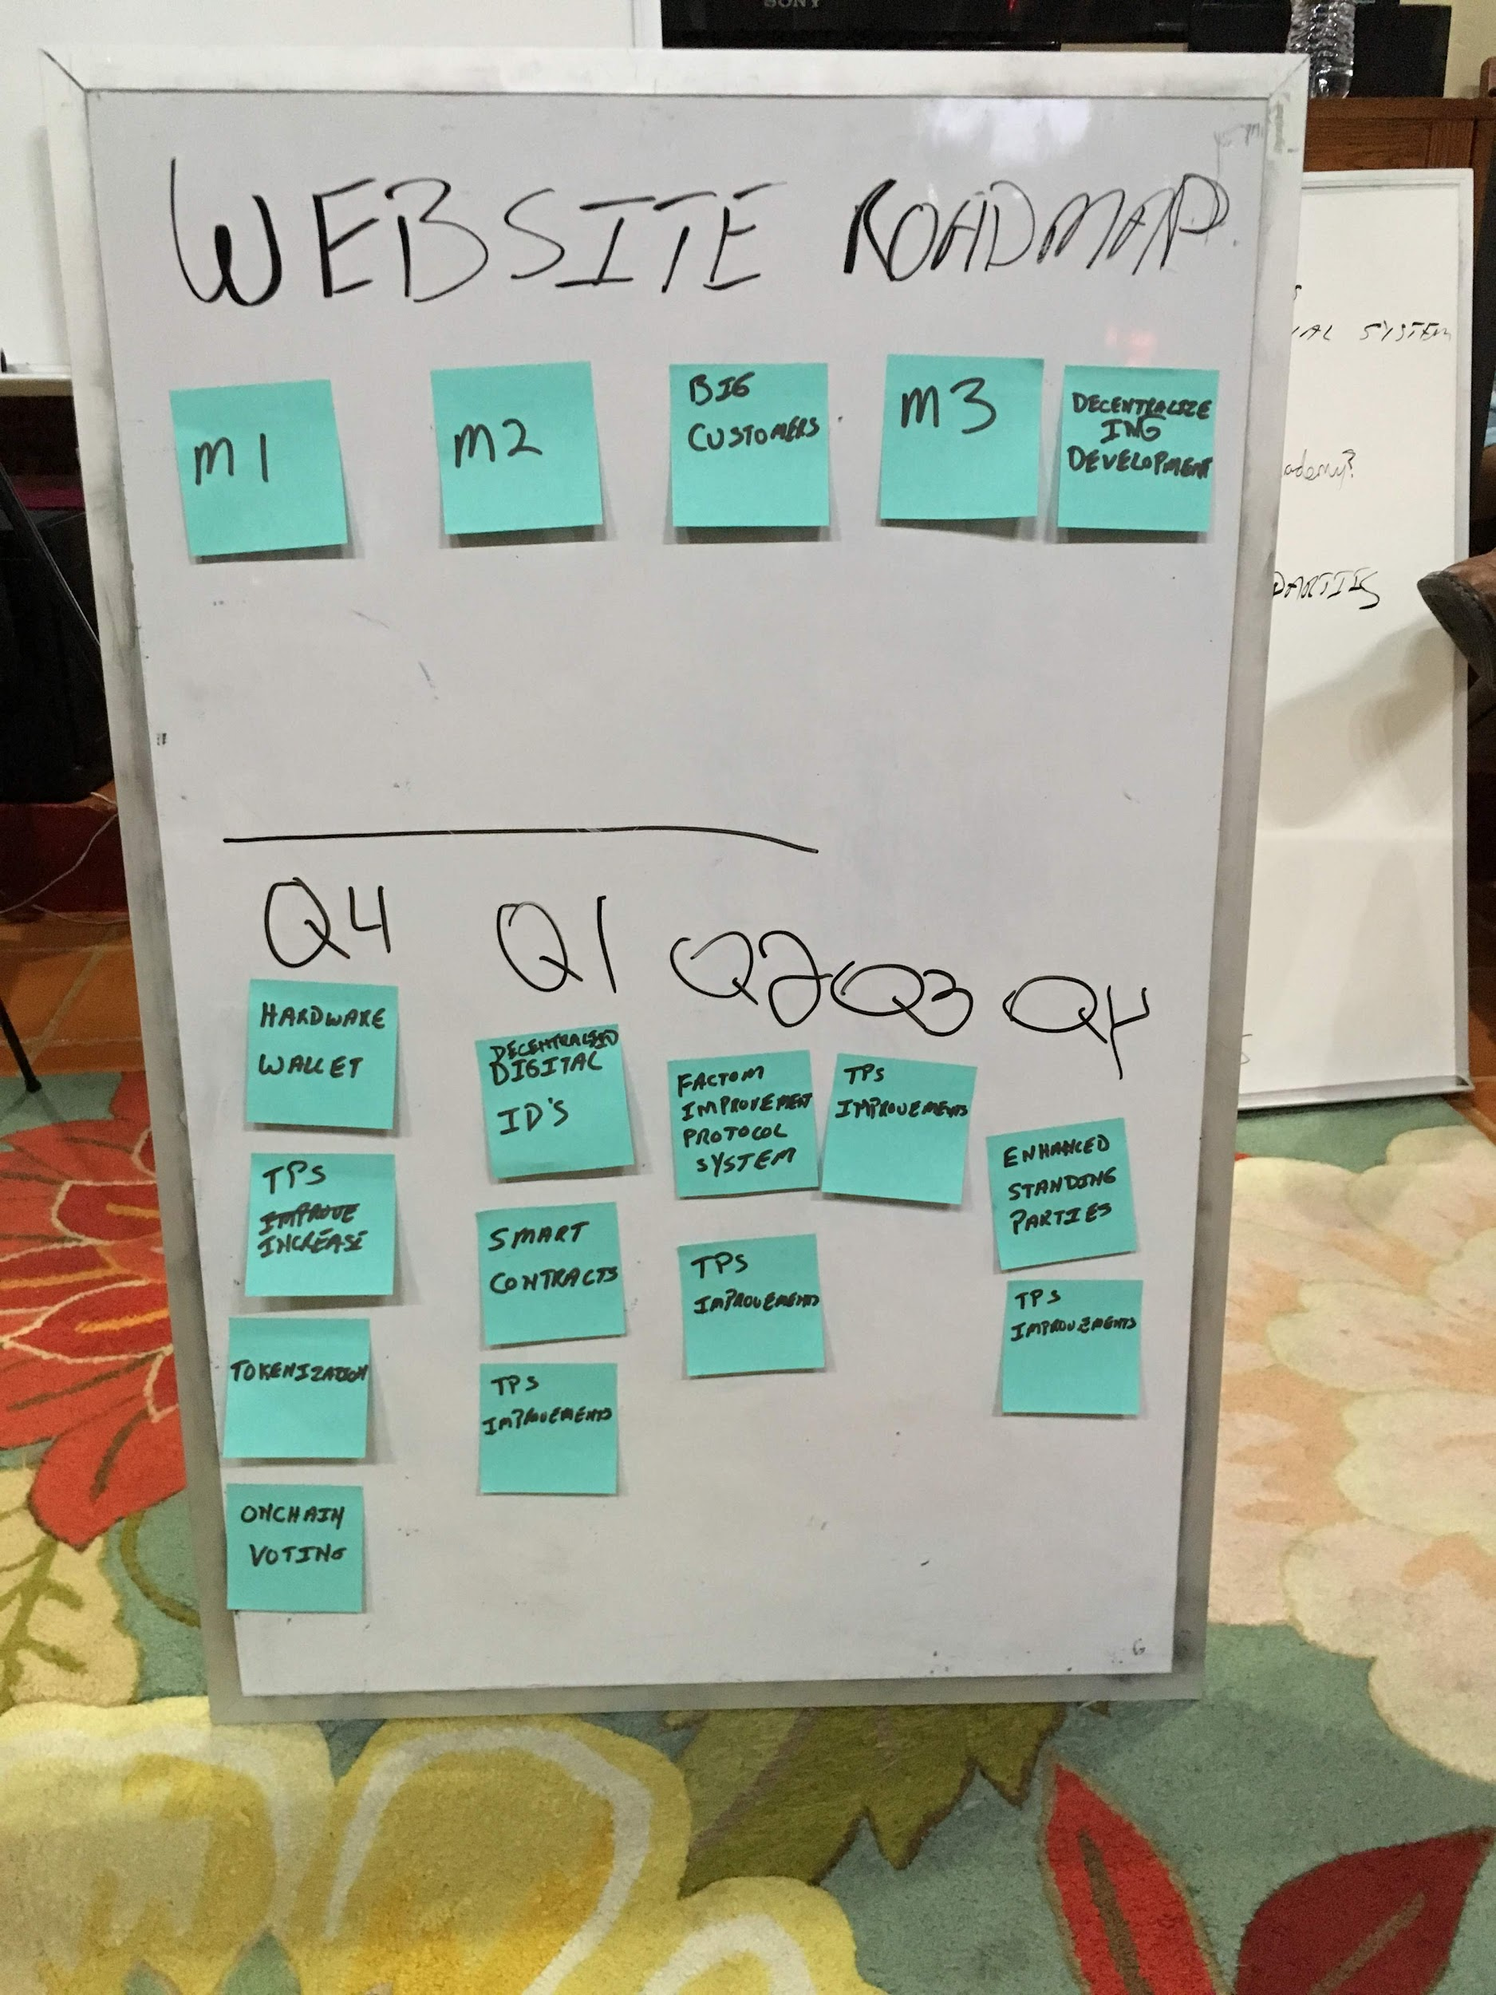

External Roadmap (Finished)

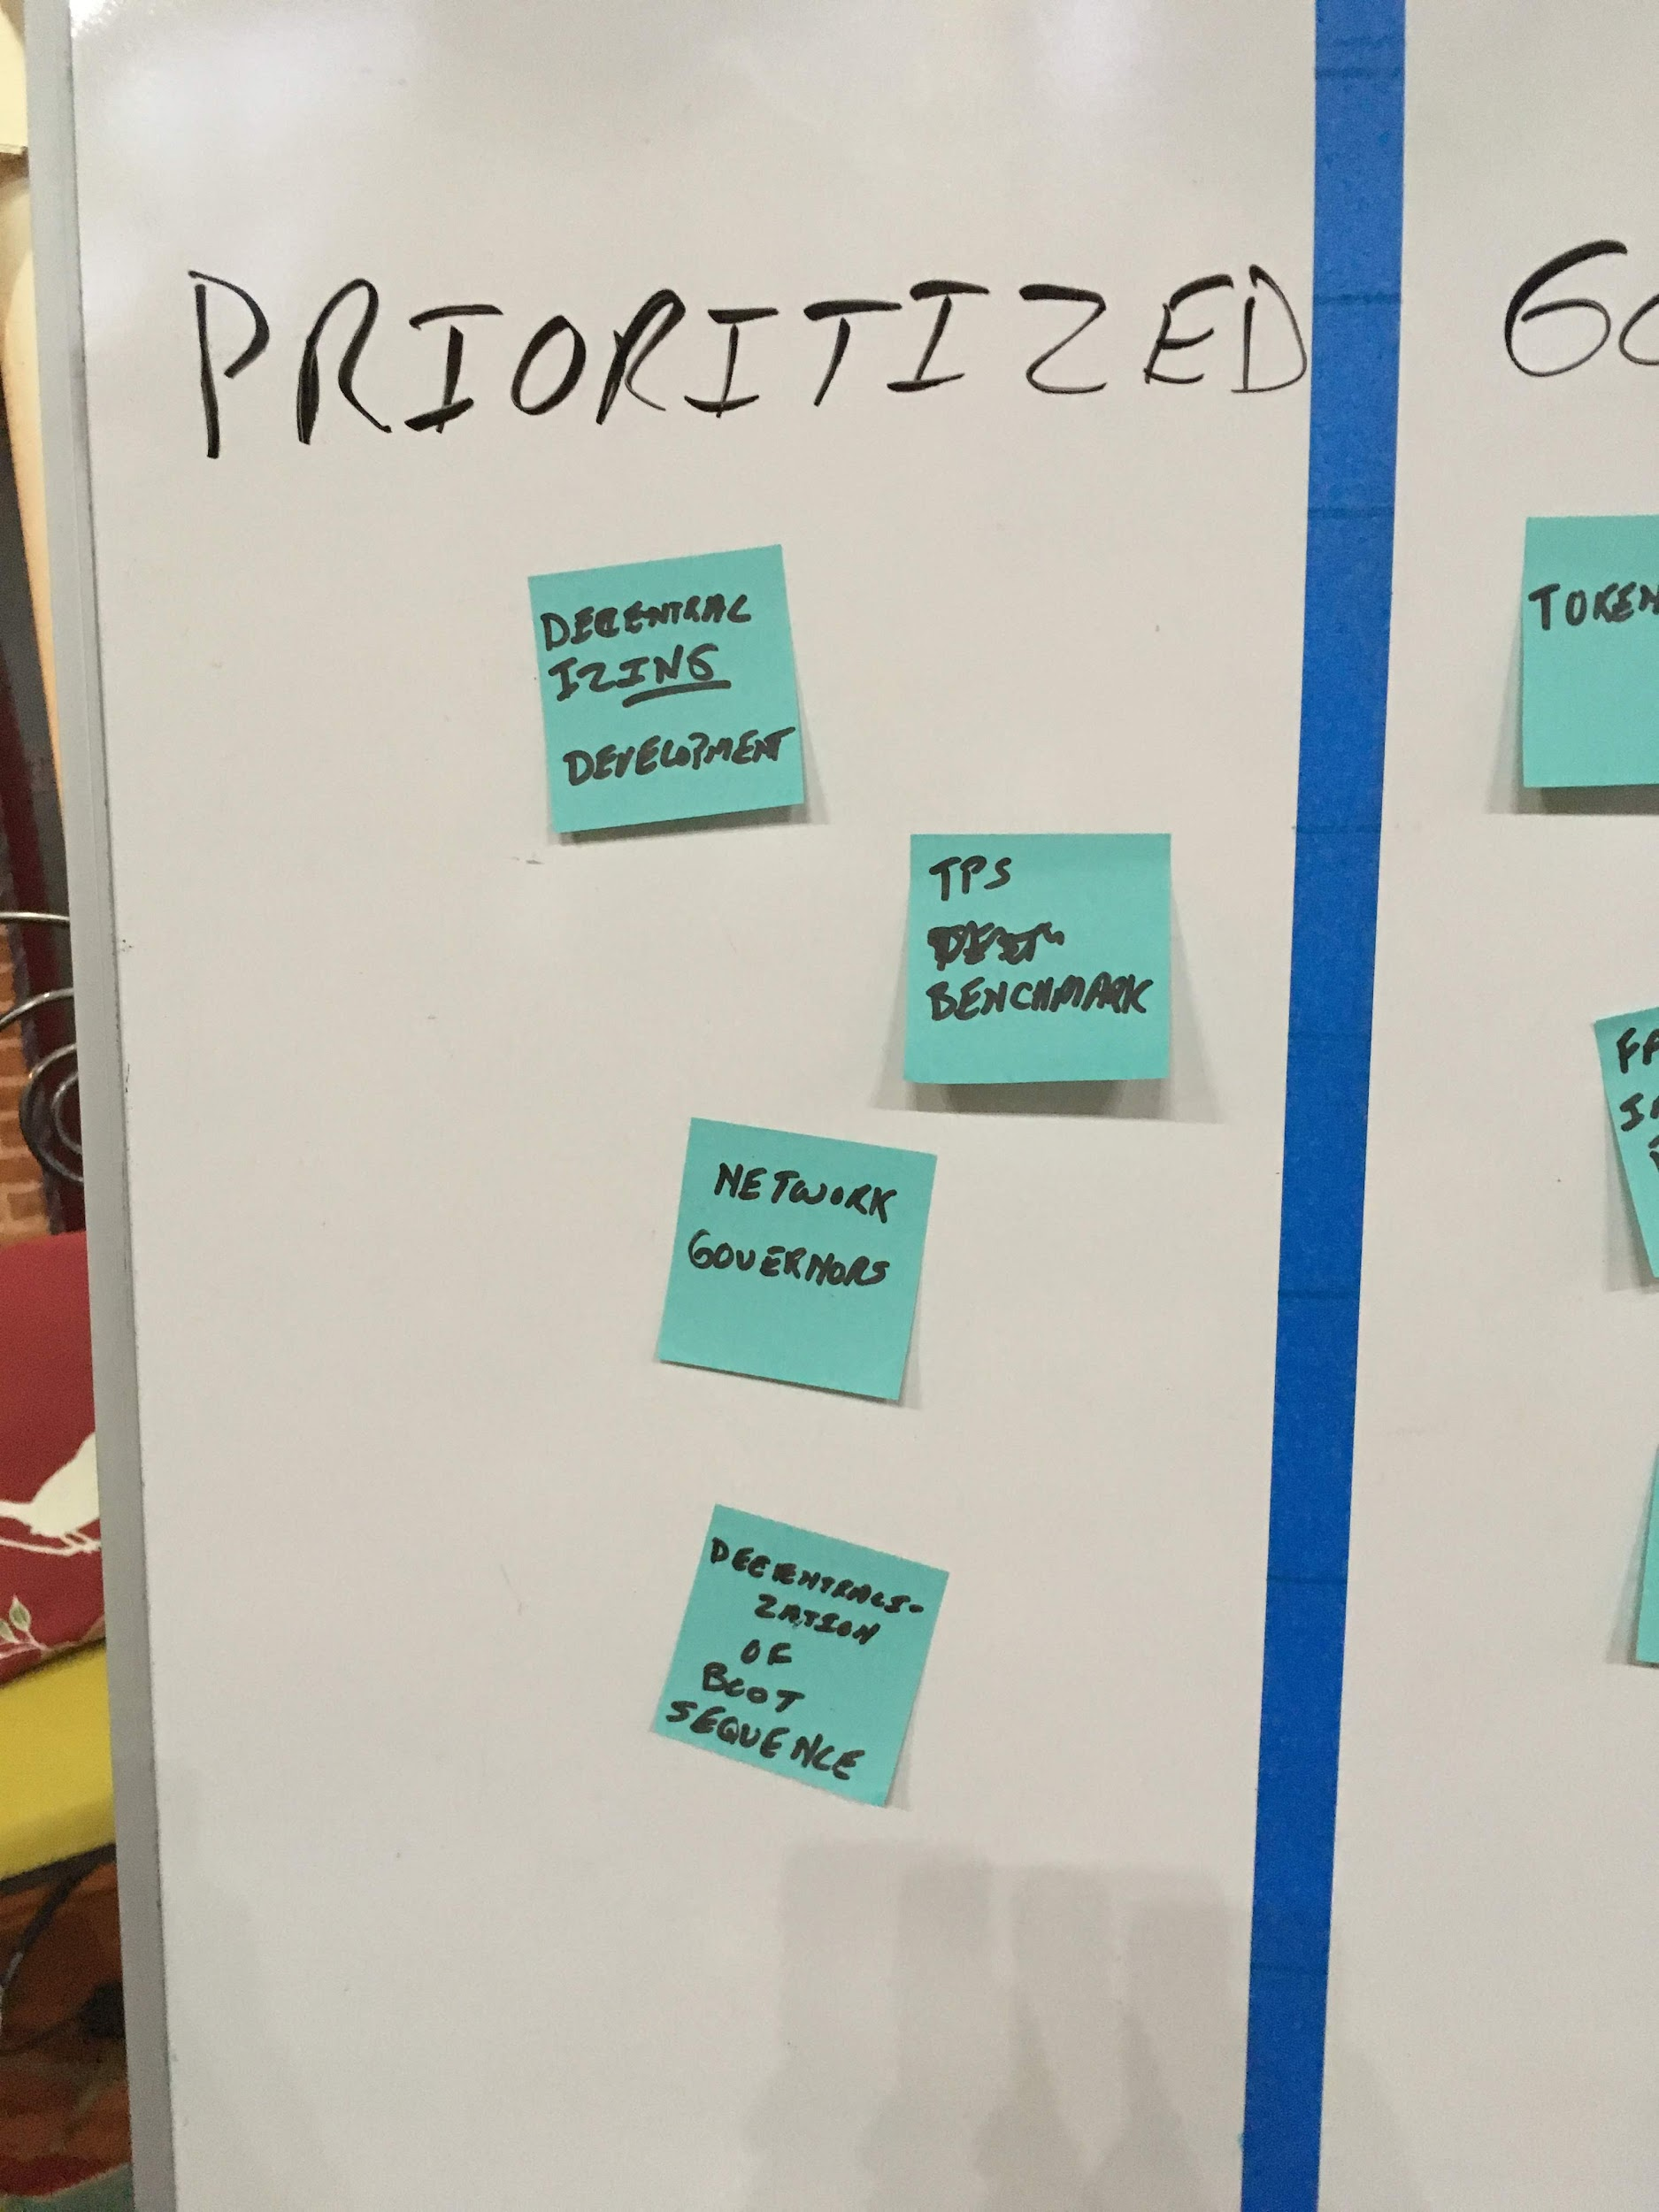

Internal Roadmap 1/3 (Unfinished)

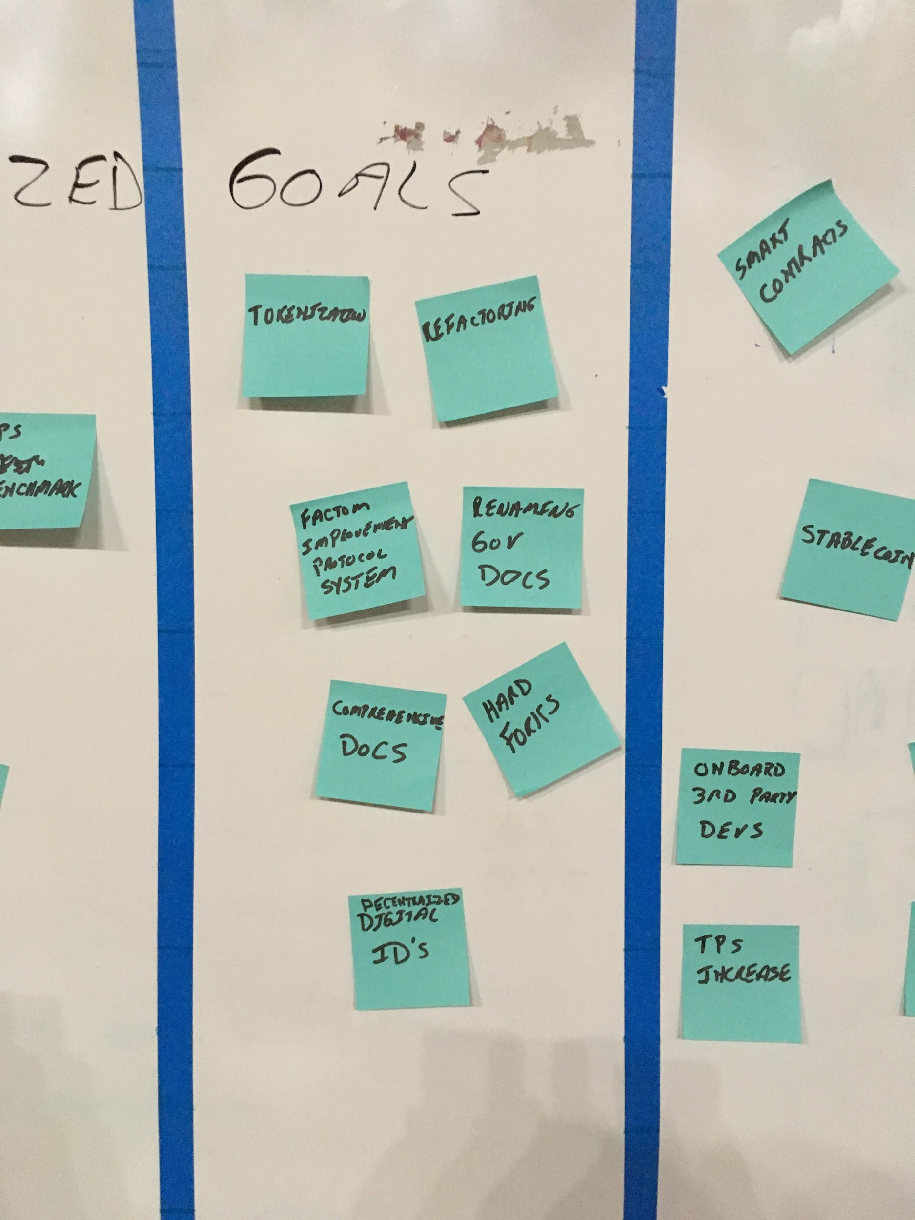

Internal Roadmap 2/3 (Unfinished)

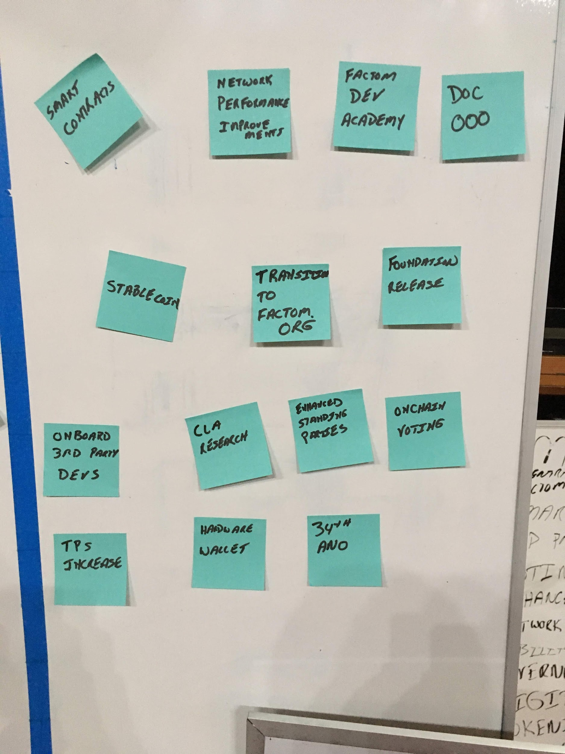Internal Roadmap 3/3 (Unfinished)

**\*\*\* End of Meeting \*\*\***

**\*\*\* @BenJ organized the internal and external roadmap on Trello \*\*\*** <https://factomize.com/forums/threads/roadmap-prioritisation-and-high-level-specification.1072/#post-6474>